WORKSHEET

PRACTICAL-1

# NAME: Adya Singhal

# ROLL No.: 2410110027

# SNU-Id: as401@snu.edu.in

# COURSE: MED201

# BATCH: PA

# STREAM: BTech CSE

Open the Al.vasp and NaCl.vasp files in VESTA application to solve the problems.

**ANSWER 1**

To find the lattice parameters of Al and NaCl, open the .vasp file in a text editor.

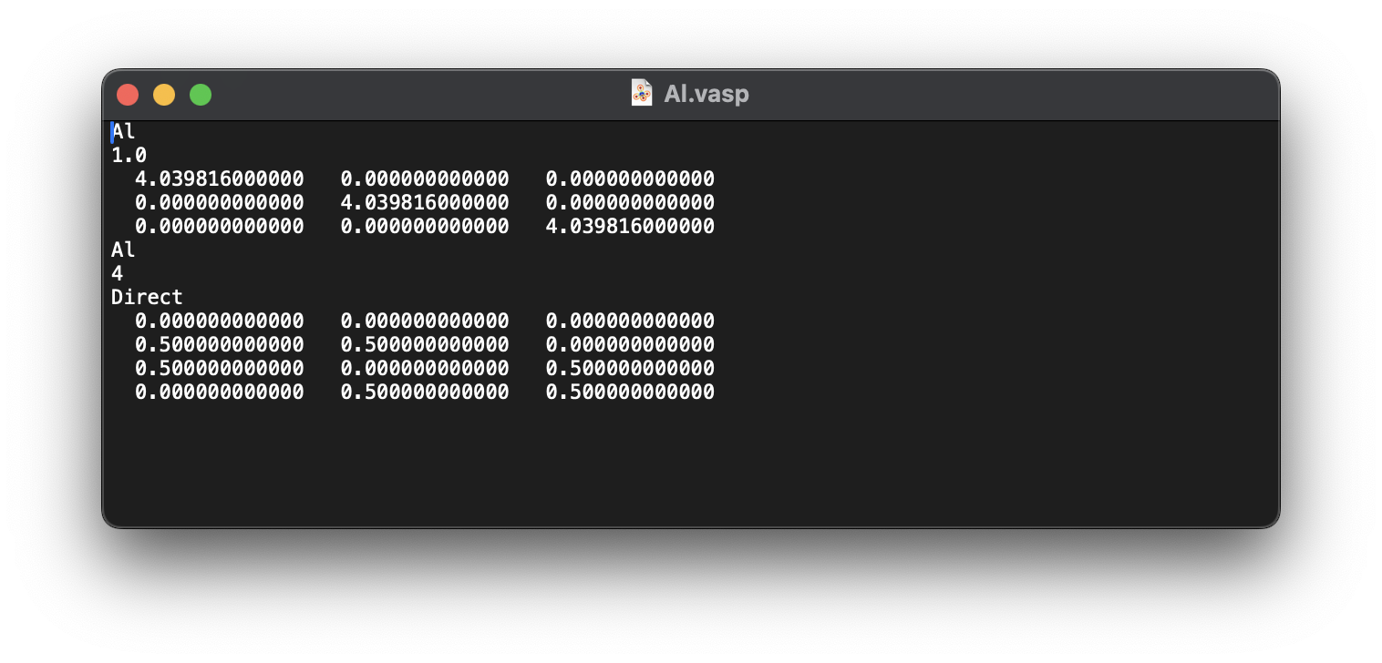

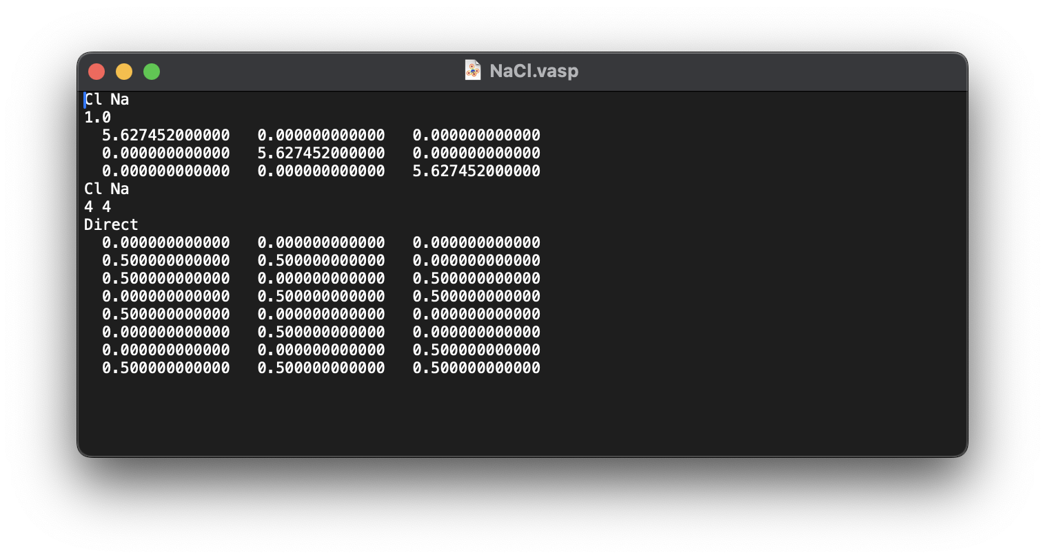

We get the following results:

|  |  |
| --- | --- |
| For Al | For NaCl |
| a = 4.0398160 Å | a = 5.6274520 Å |
| b = 4.0398160 Å | b = 5.6274520 Å |
| c = 4.0398160 Å | c = 5.6274520 Å |

Then to find angles we open the files in VESTA and go to summary tab.

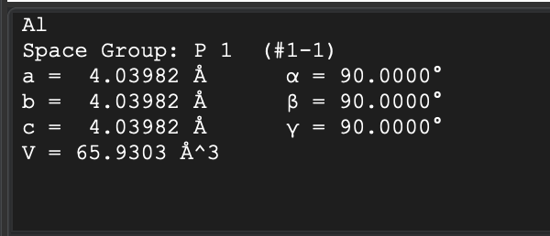

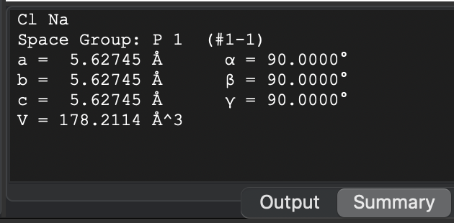

We get the following results:

|  |  |
| --- | --- |
| For Al | For NaCl |
| α =90º | α =90º |
| β =90º | β =90º |
| γ =90º | γ =90º |

**ANSWER 2**

After importing the structure in Vesta, go to Edit>Bonds and add a new bond to see bond line structures as follows:

**For Al:**

Set the max length as 2.9 as shown below.

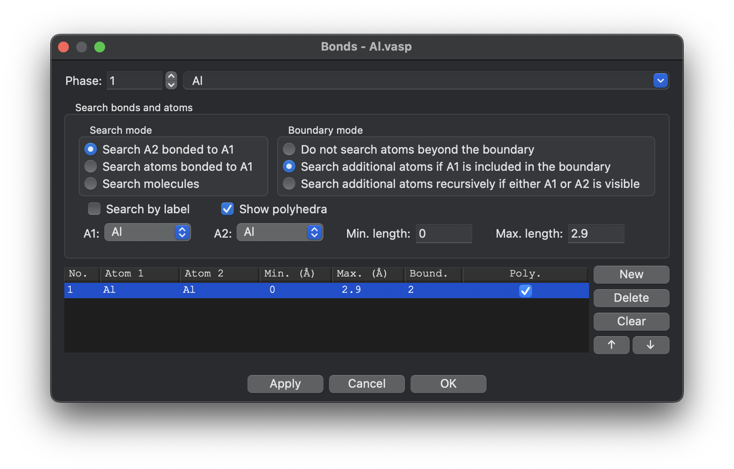

We click on 2 atoms options in the corner (circled below) and then we click on 2 Al atoms (as pointed by arrows in the below screenshot) to obtain interatomic distance of Al-Al.

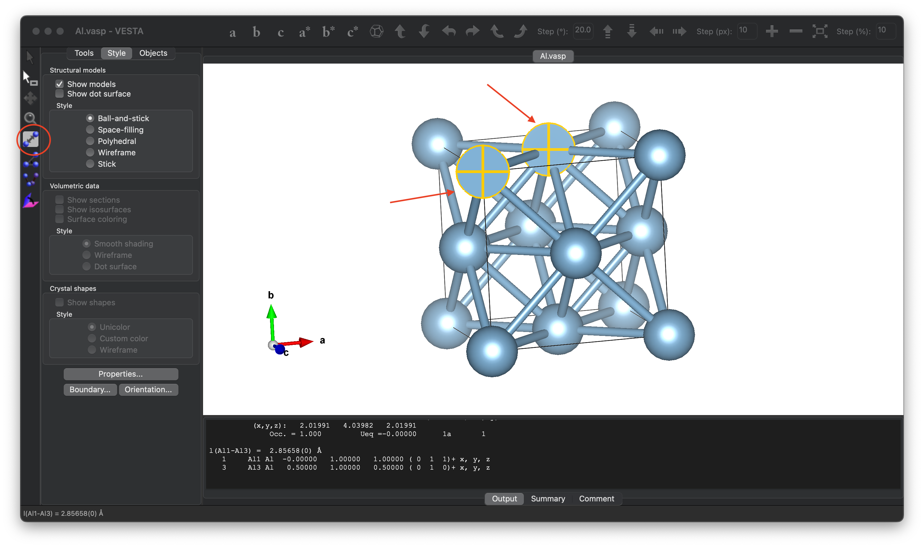

From this, we conclude:

**Inter atomic distance of Al-Al is 2.85658 Å.**

**For NaCl:**

We click on 2 atoms options in the corner (circled below) and then we click on an Na atom and a Cl atom (as pointed by arrows in the below screenshot) to obtain interatomic distance of Na-Cl.

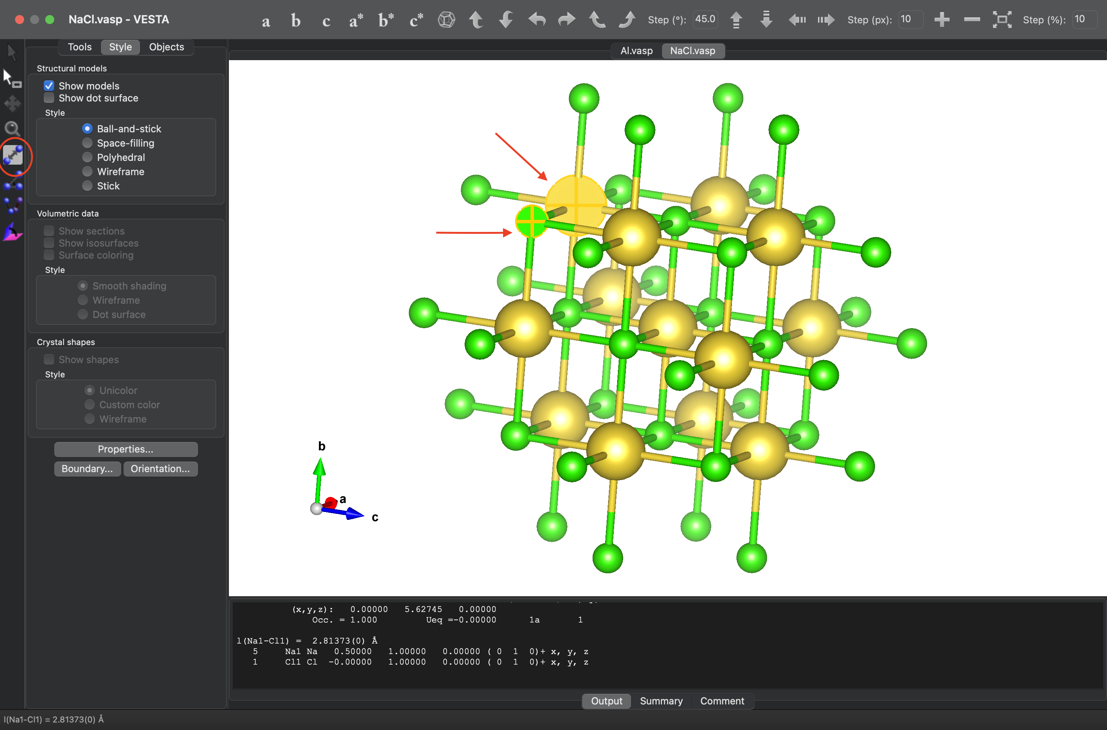

From this, we conclude:

**Inter atomic distance of Na-Cl is 2.81373 Å.**

We repeat the same steps to find inter-atomic distances of Na-Na and Cl-Cl.

(Atoms taken are marked by arrows)

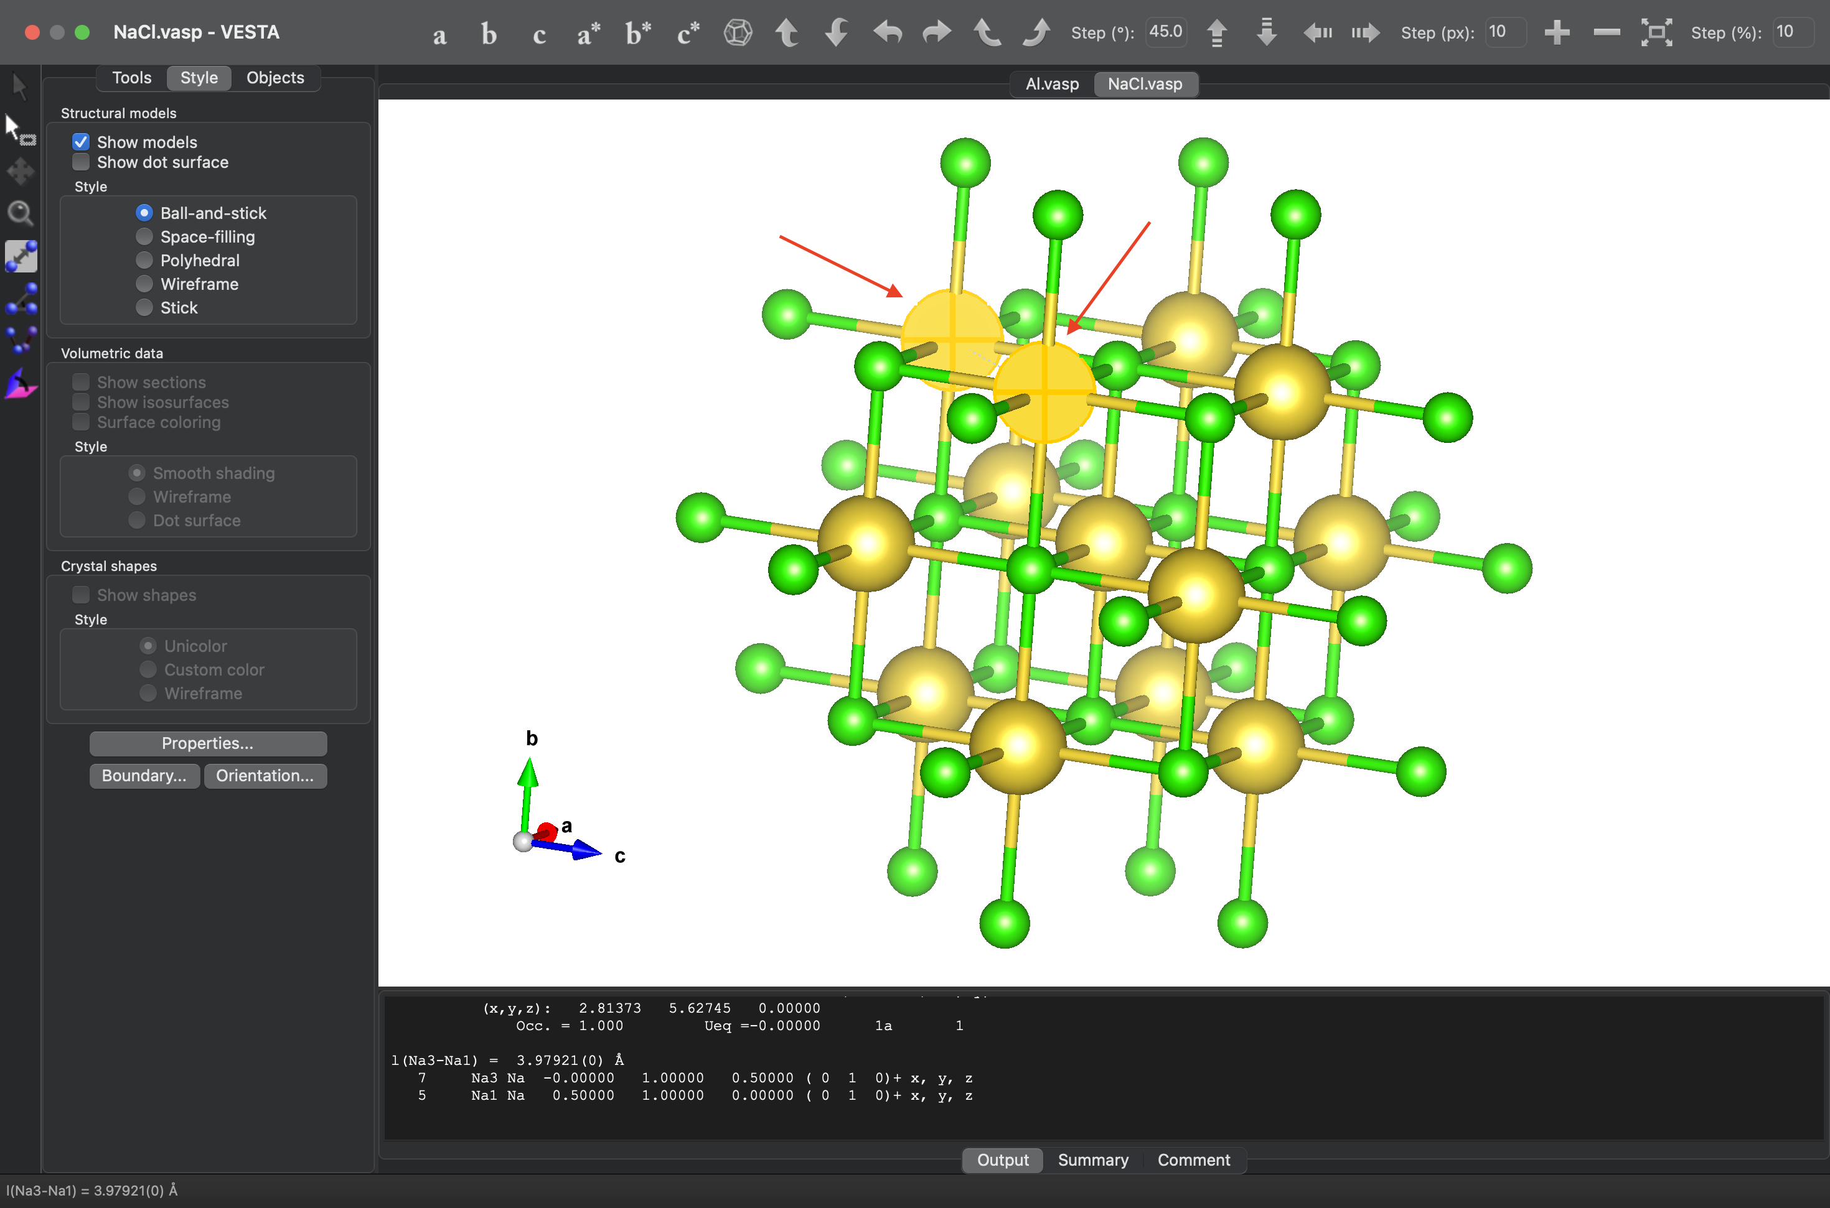

From this, we conclude:

**Inter atomic distance of Na-Na is 3.979210 Å.**

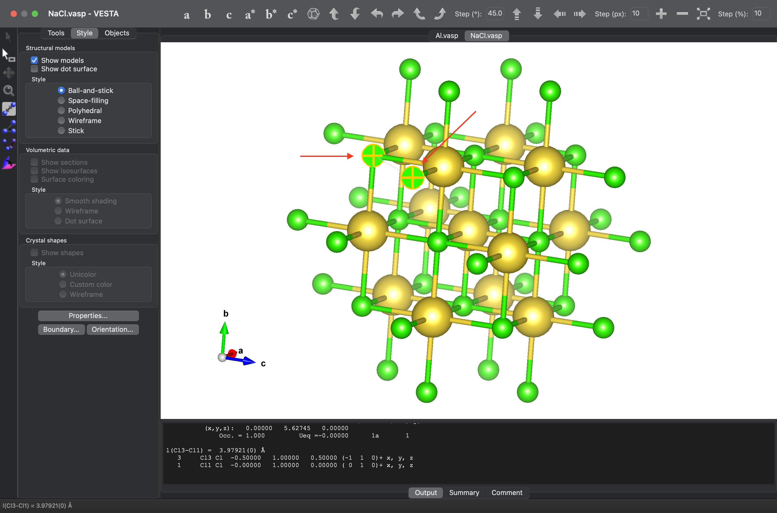

From this, we conclude:

**Inter atomic distance of Cl-Cl is 3.979210 Å.**

**ANSWER 3**

Now we find the angles between atoms.

We click on 3 atoms options in the corner (circled below) and then we click on 3 atoms (as pointed by arrows in the below screenshot) to obtain angle between them.

**For Al:**

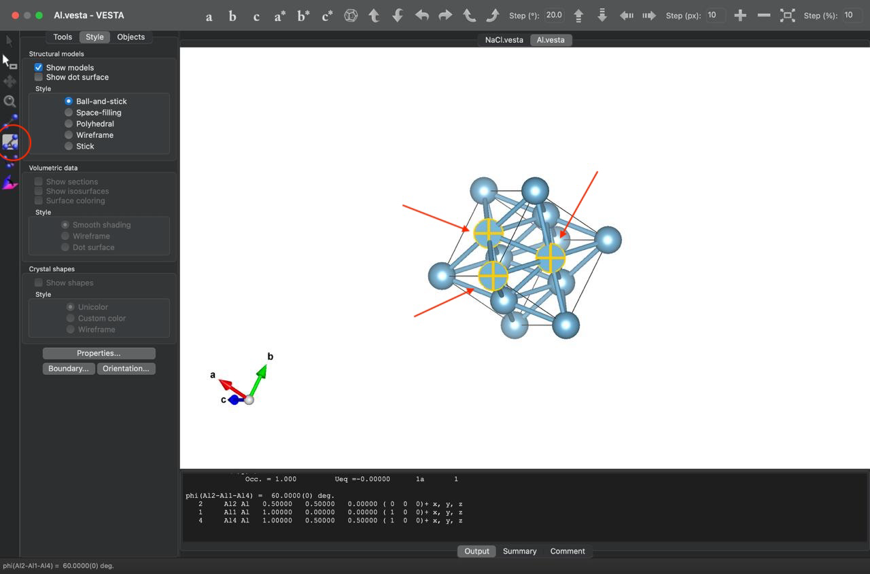

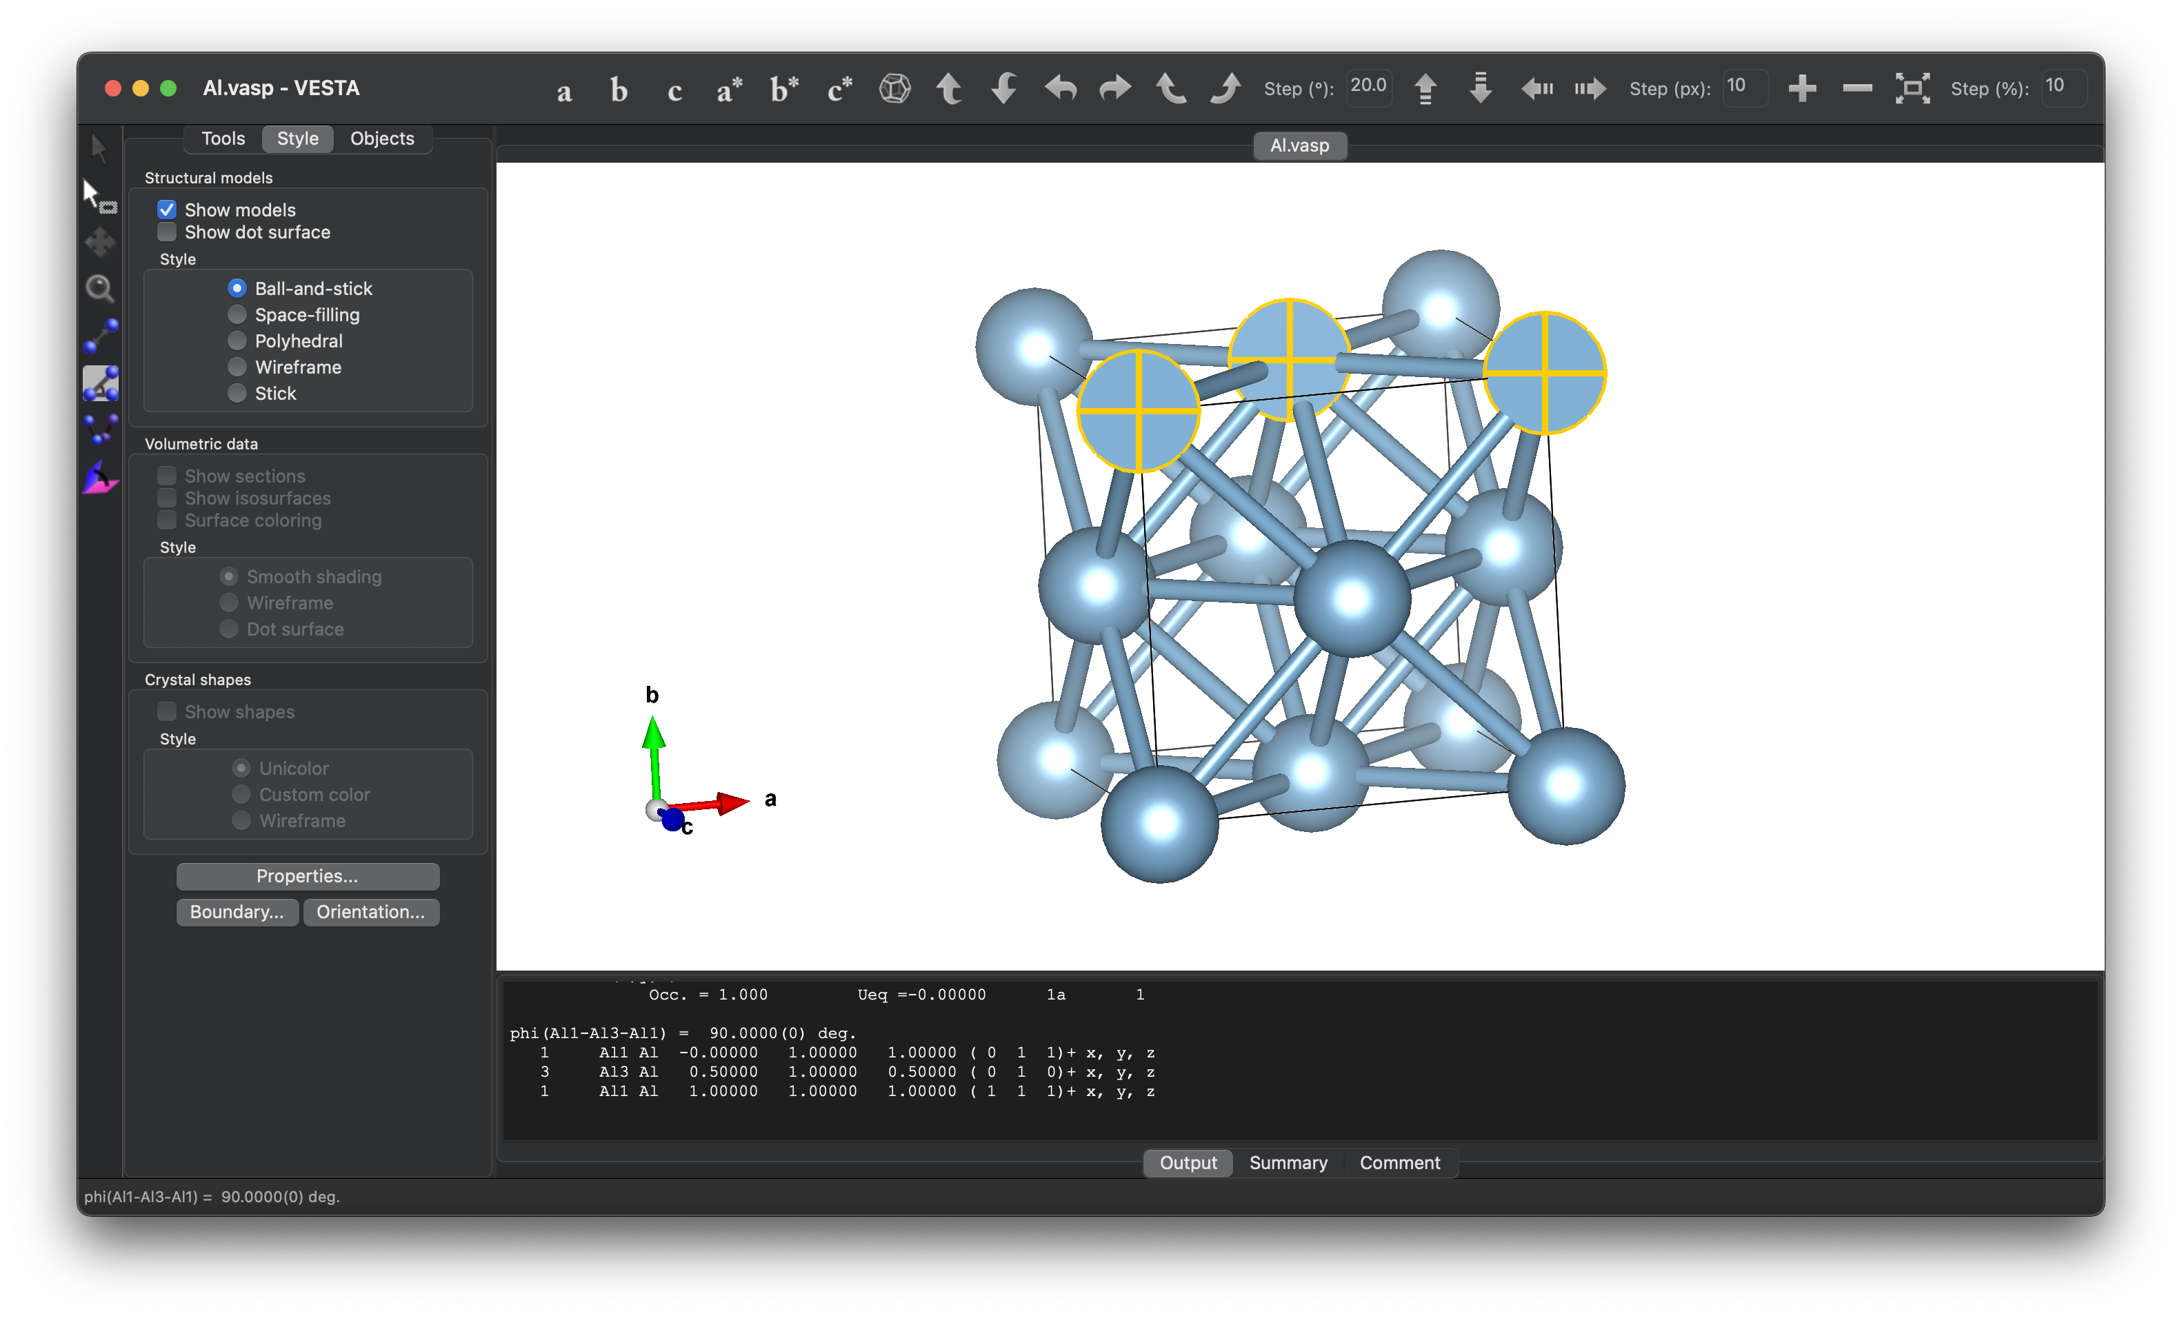

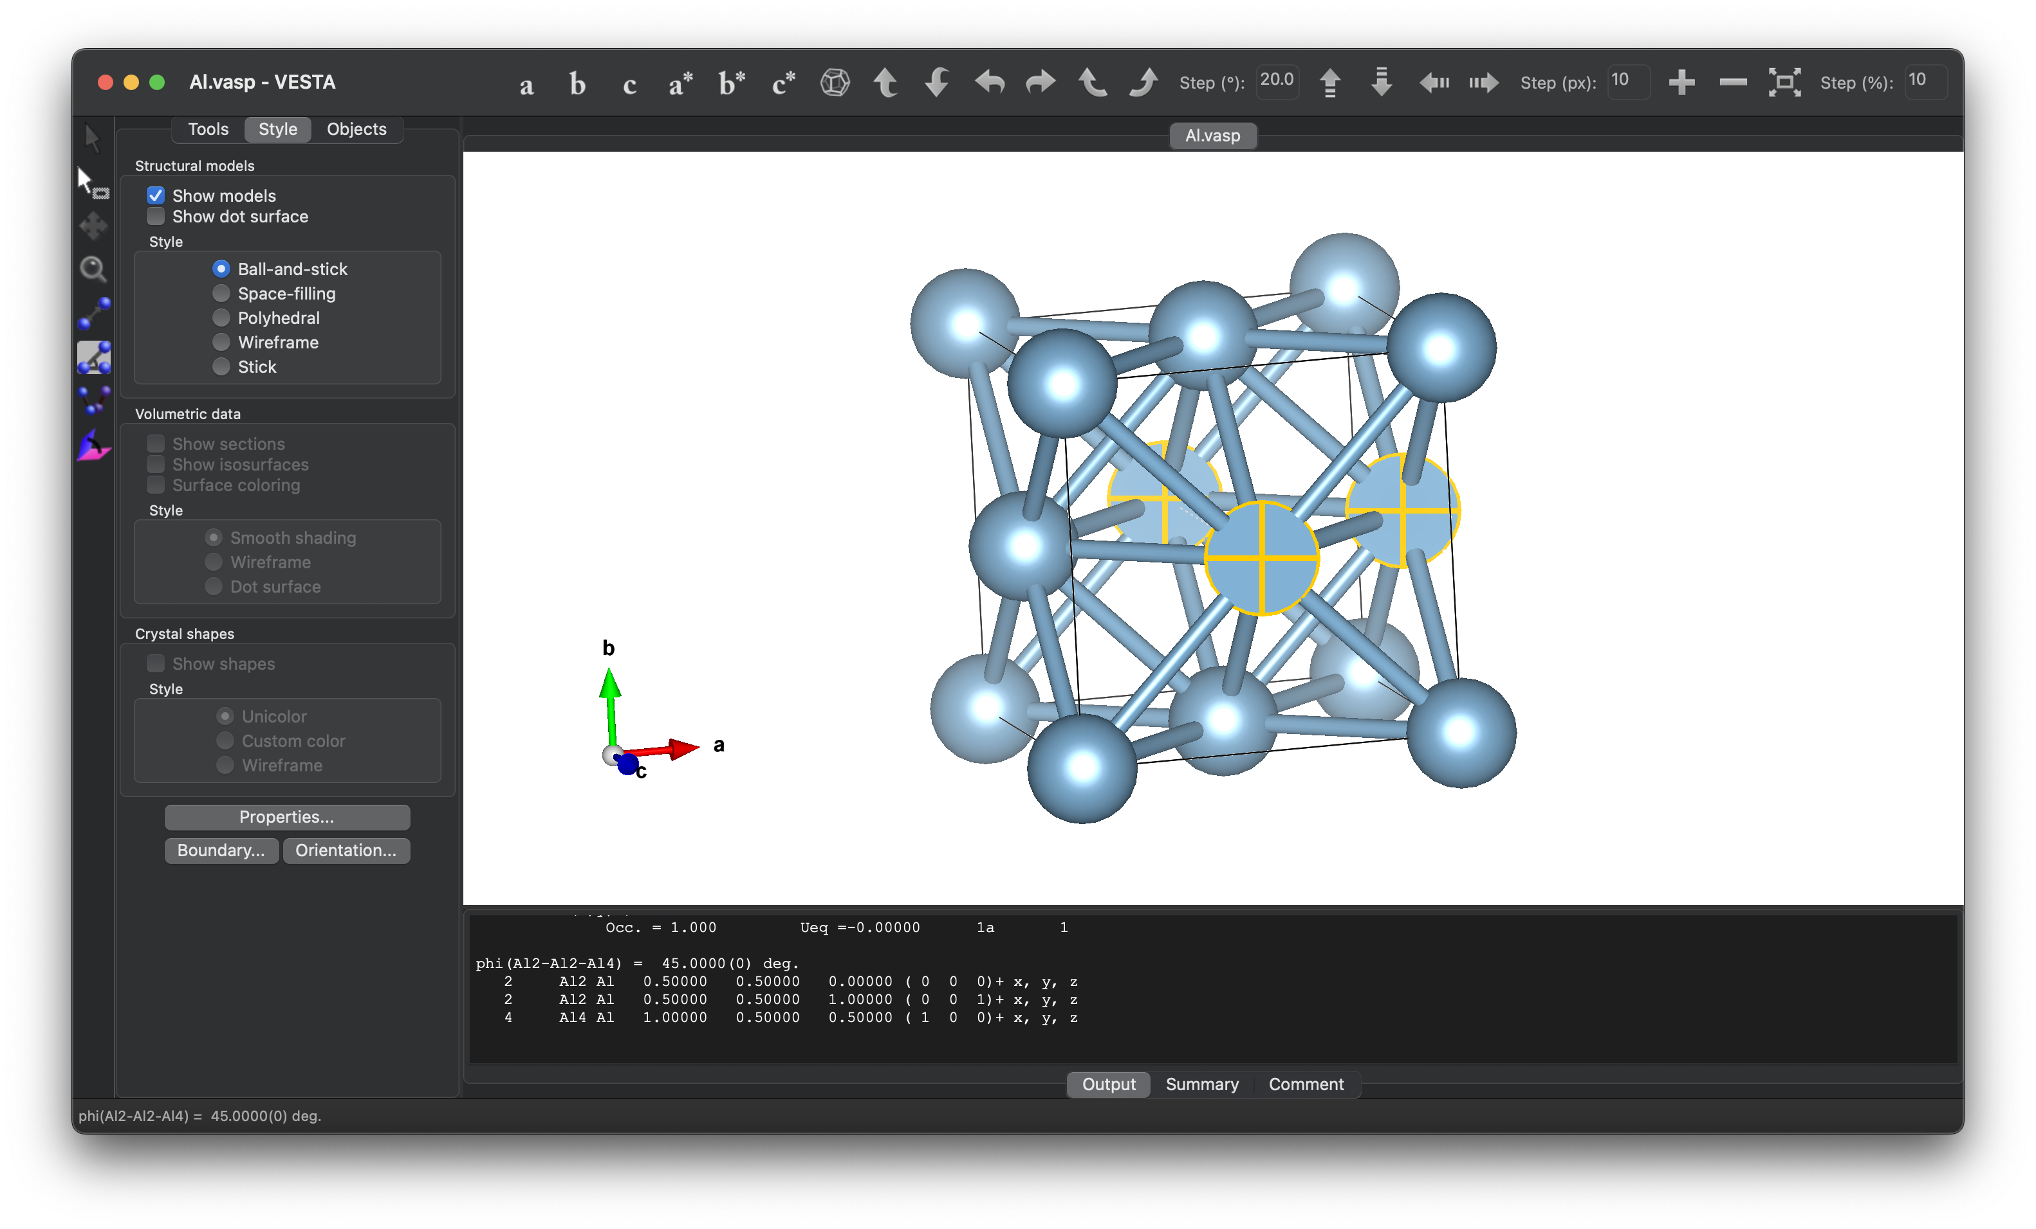

From this, we conclude:

**Al-Al-Al angle is 60º, 90º, 45º respectively.**

**For Na:**

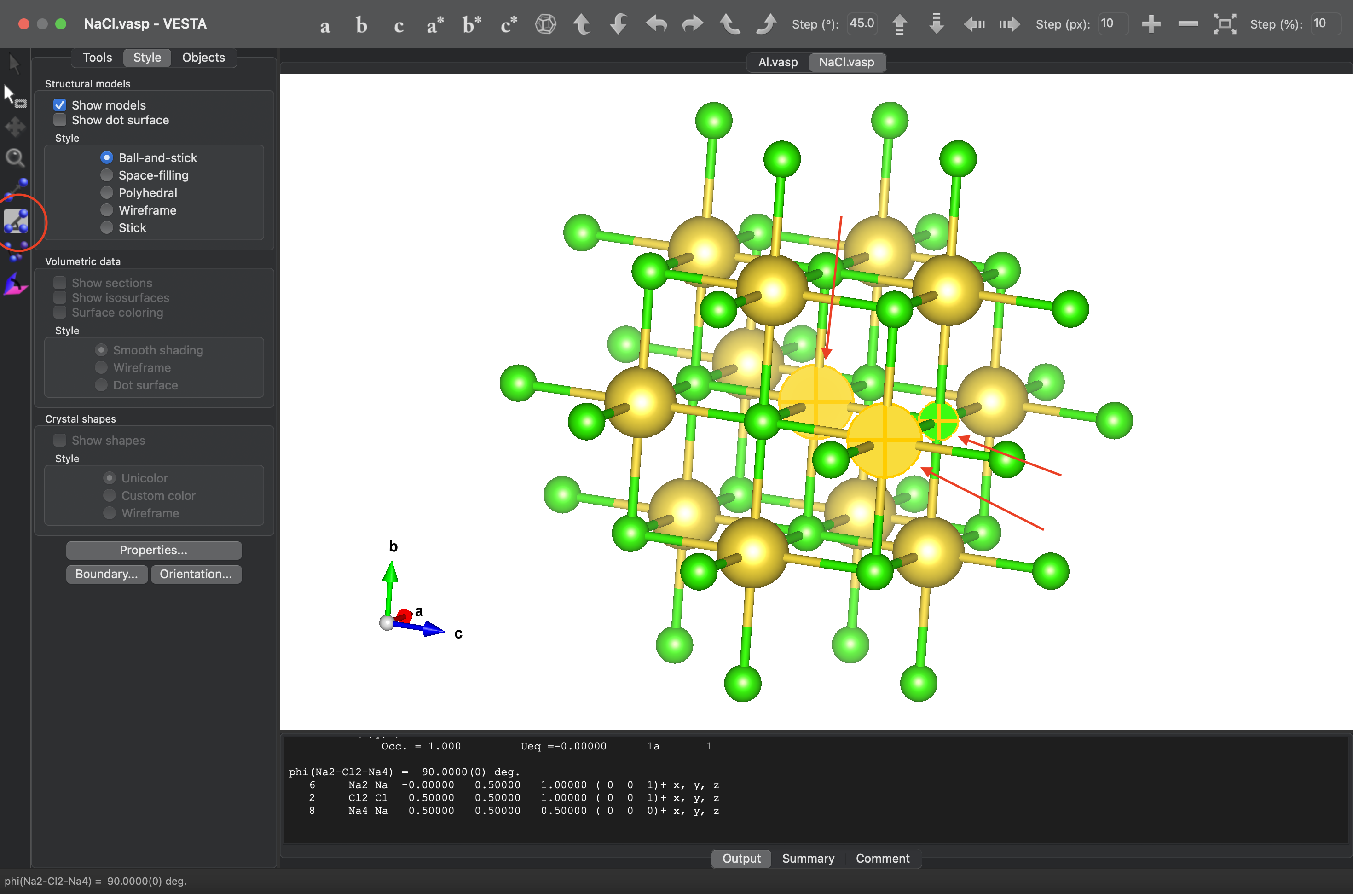

From this, we conclude:

**Na-Cl-Na angle is 90º.**

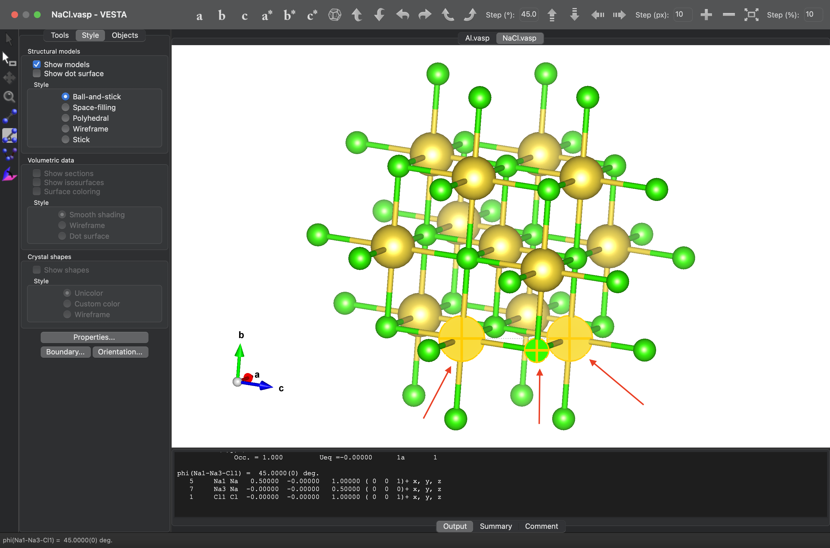

From this, we conclude:

**Na-Na-Cl angle is 45º.**

**ANSWER 4**

To rotate the structure about c-axis by 30º and b- axis by 20º, we follow some steps-

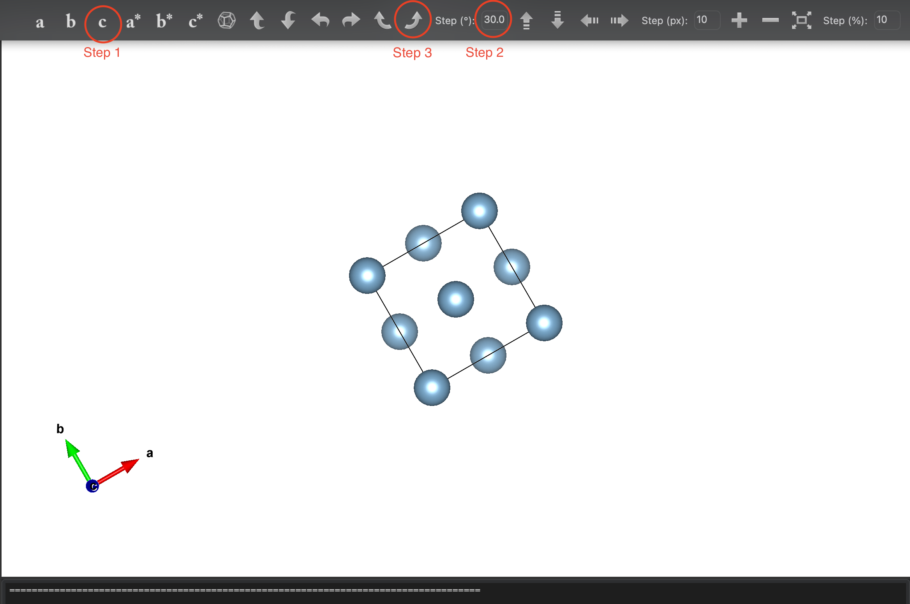

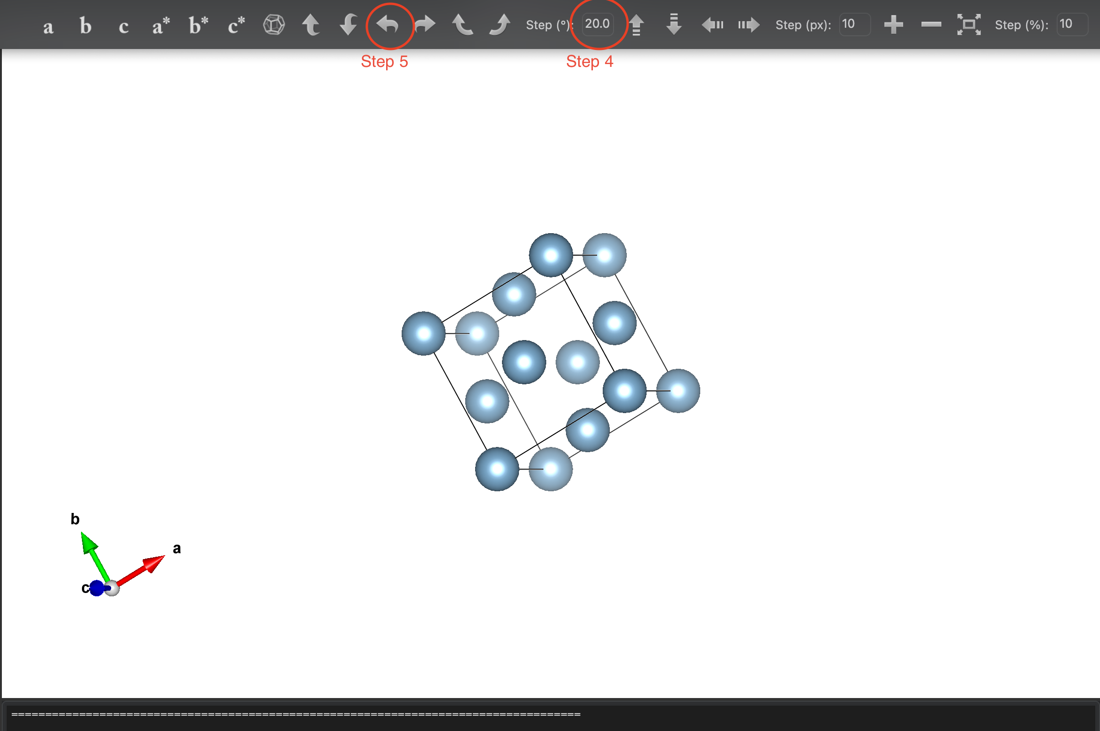

Step-1: Position structure with respect to c-axis.

Step-2: Set the angle to 30º.

Step-3: Turn using the marked arrow to rotate about c-axis.

Step-4: Change the angle to 20º.

Step-5: Turn using marked arrow to rotate about b-axis.

We obtain the following picture:

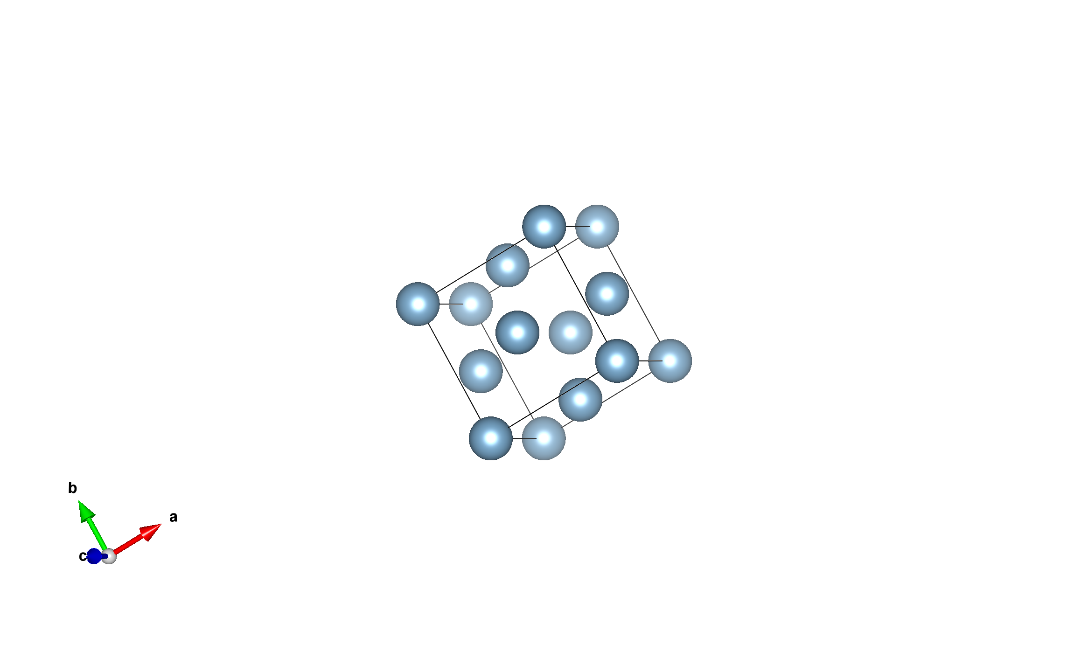

**ANSWER 5**

Aluminium (Al) has a face-centred cubic (FCC) structure, where each atom has 12 nearest neighbours.

Focus on the atom at (0.5, 0.0, 0.5).

Adjust the coordinates by adding or subtracting in the x, y, and z directions.

The coordinates of the nearest neighbours are:

(0.5, 0.0, 0.0)

(0.5, 0.0, 1.0)

(0.0, 0.0, 0.5)

(1.0, 0.0, 0.5)

(0.5, 0.5, 0.0)

(0.5, 0.5, 1.0)

(0.5, -0.5, 0.0)

(0.5, -0.5, 1.0)

(1.0, 0.5, 0.5)

(0.0, 0.5, 0.5)

(1.0, -0.5, 0.5)

(0.0, -0.5, 0.5)

**ANSWER 6**

**For Al:**

To construct displacement vectors, we go to Edit>Vectors

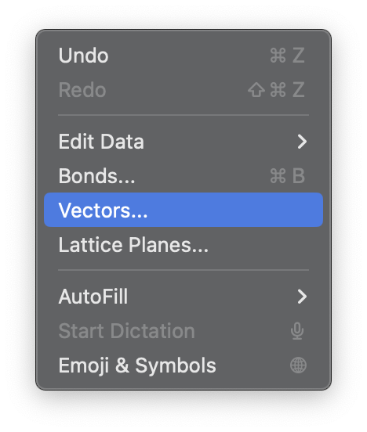

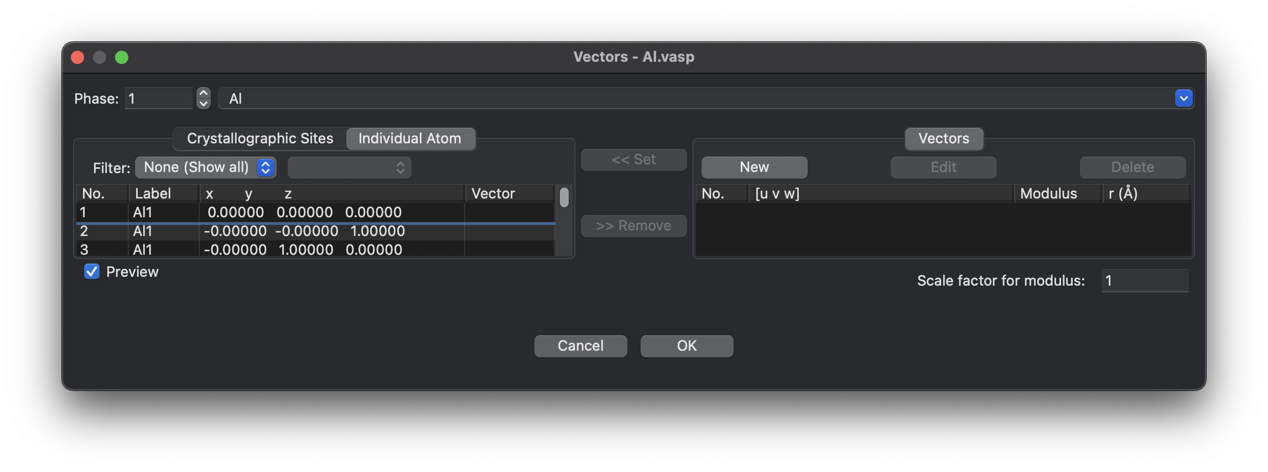

Window shown above appears, click on “New”

Set [u v w] =[ 1 1 0] and deselect the penetrate atoms.

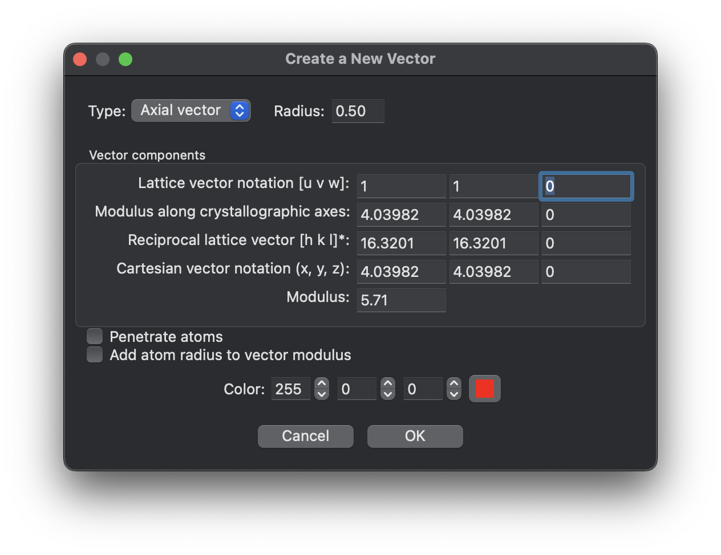

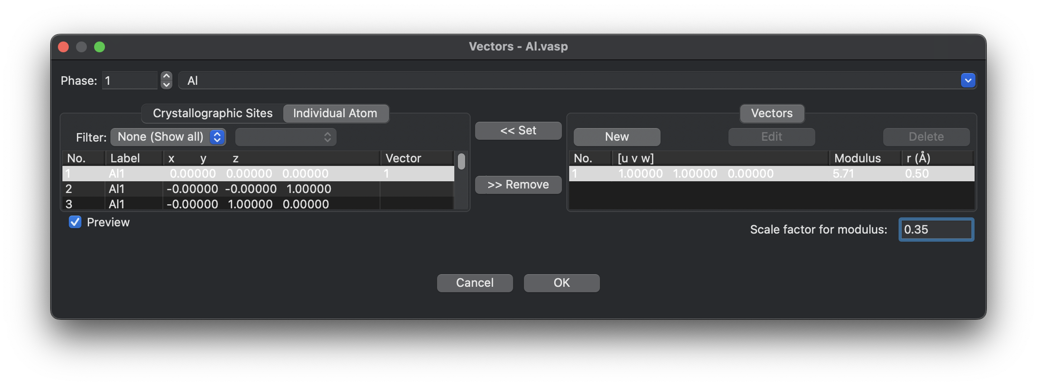

Map the vector created with the coordinates of the desired atom by clicking on Set and set the scaling factor to 0.35.

We obtain the following image:

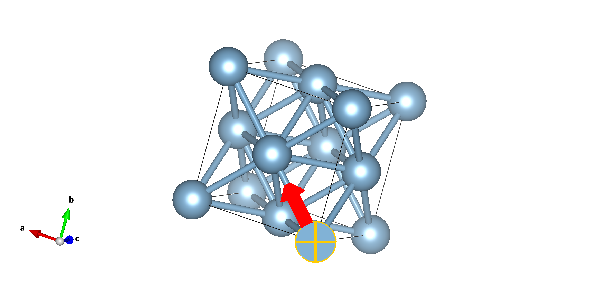

Now, we repeat the same steps to construct displacement vector on the atom at (0.5, 0.0, 0.5) along the [1 1 1] direction with scaling factor 0.35.

We obtain the following image:

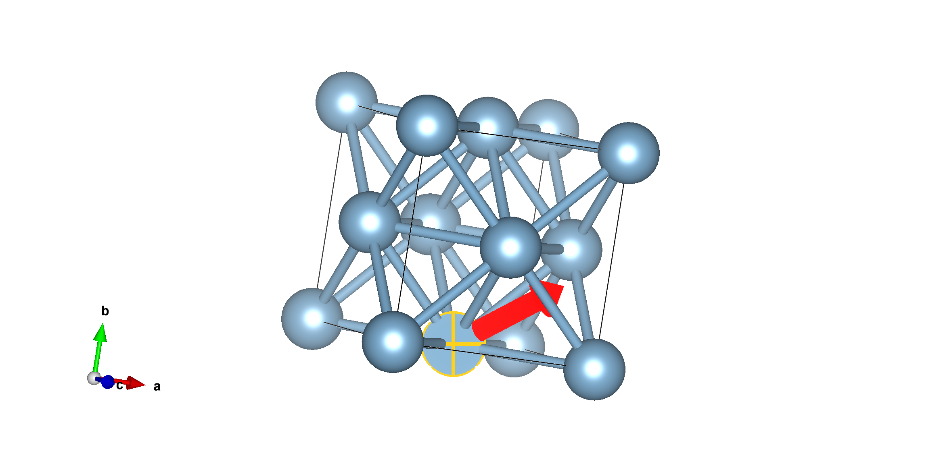

**For NaCl:**

We repeat the same steps for NaCl and obtain the following images:

For [110] vector at (0.0,0.0,0.0):

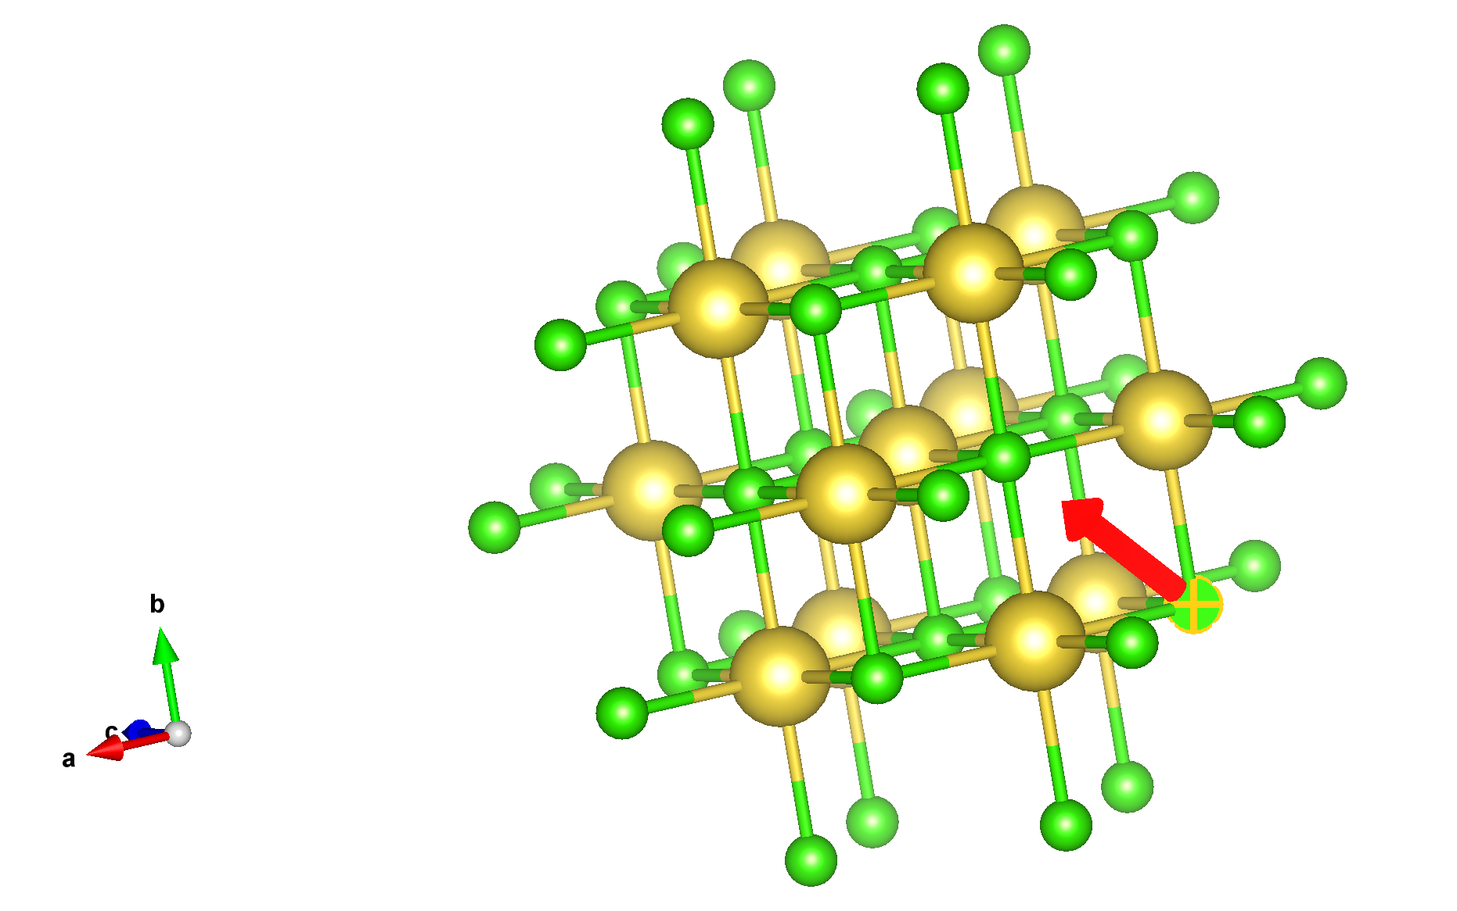

For [111] vector at (0.5,0.0,0.5):

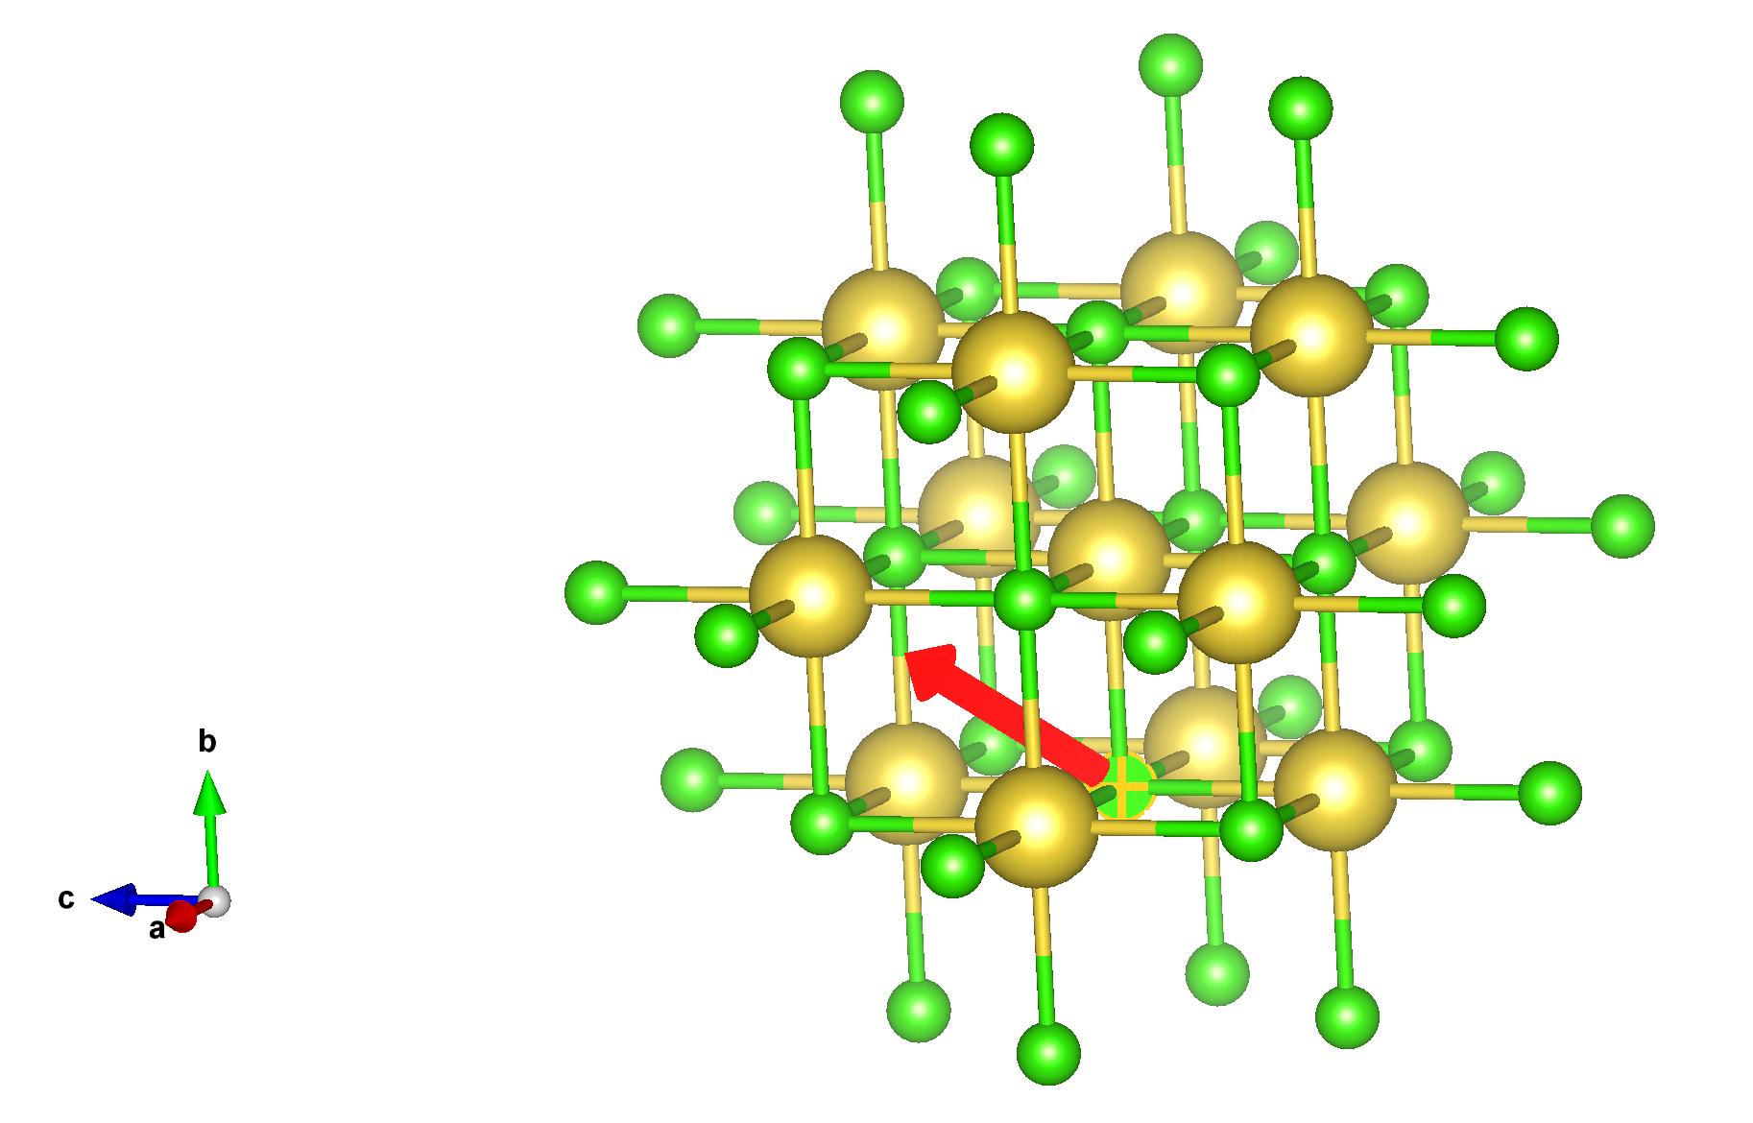

**ANSWER 7**

To construct the planes, go to Edit> Lattice Planes

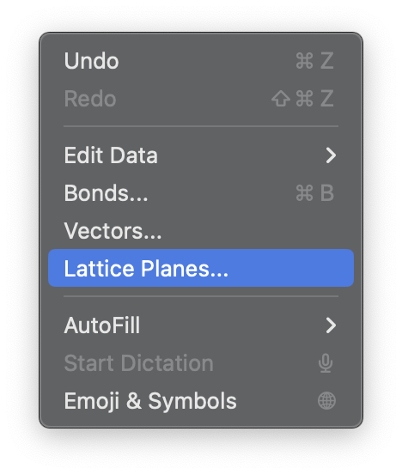

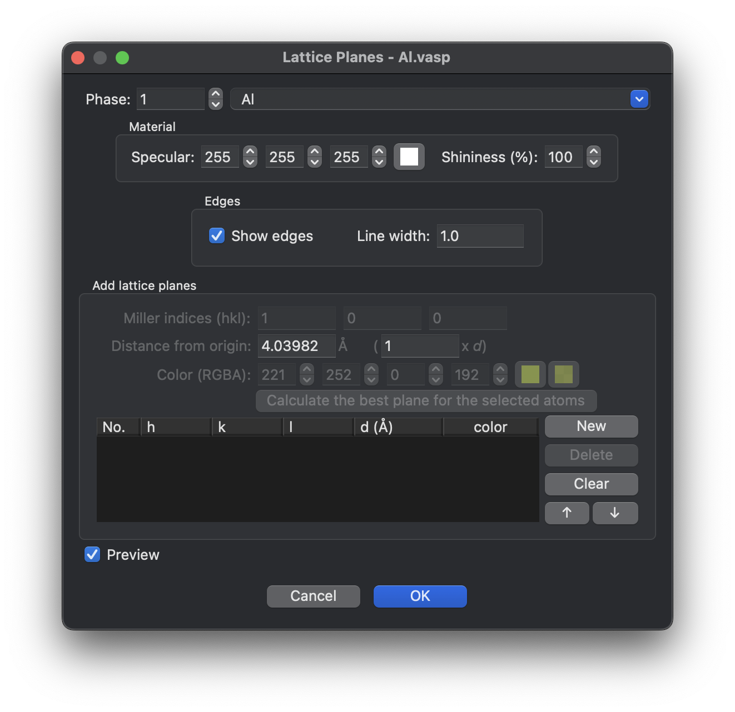

Window shown above appears, click on “New”

**For Al:**

To construct (1 1 0) plane:

Set the miller indices as 1,1,0 and set multiplier of d to 1 and click on “ok” to obtain the plane.

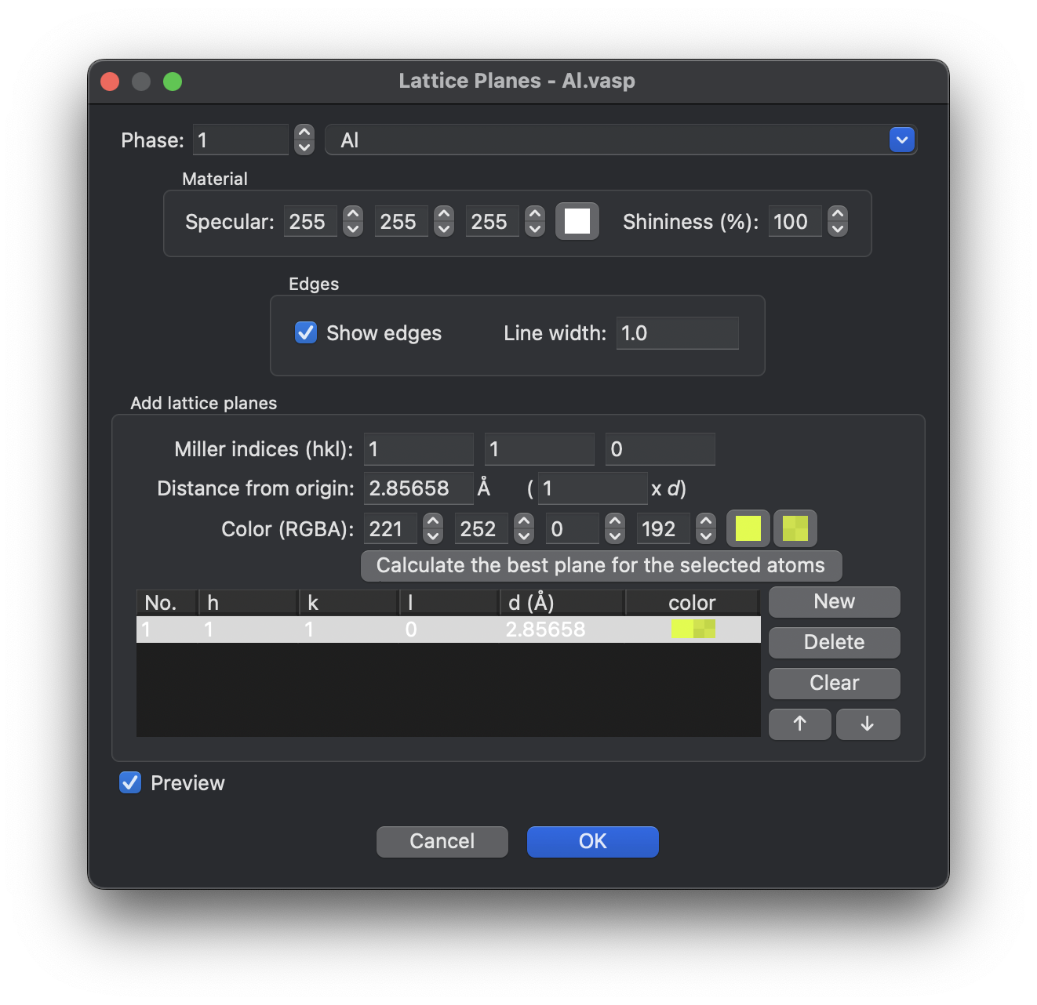

We obtain the following figure:

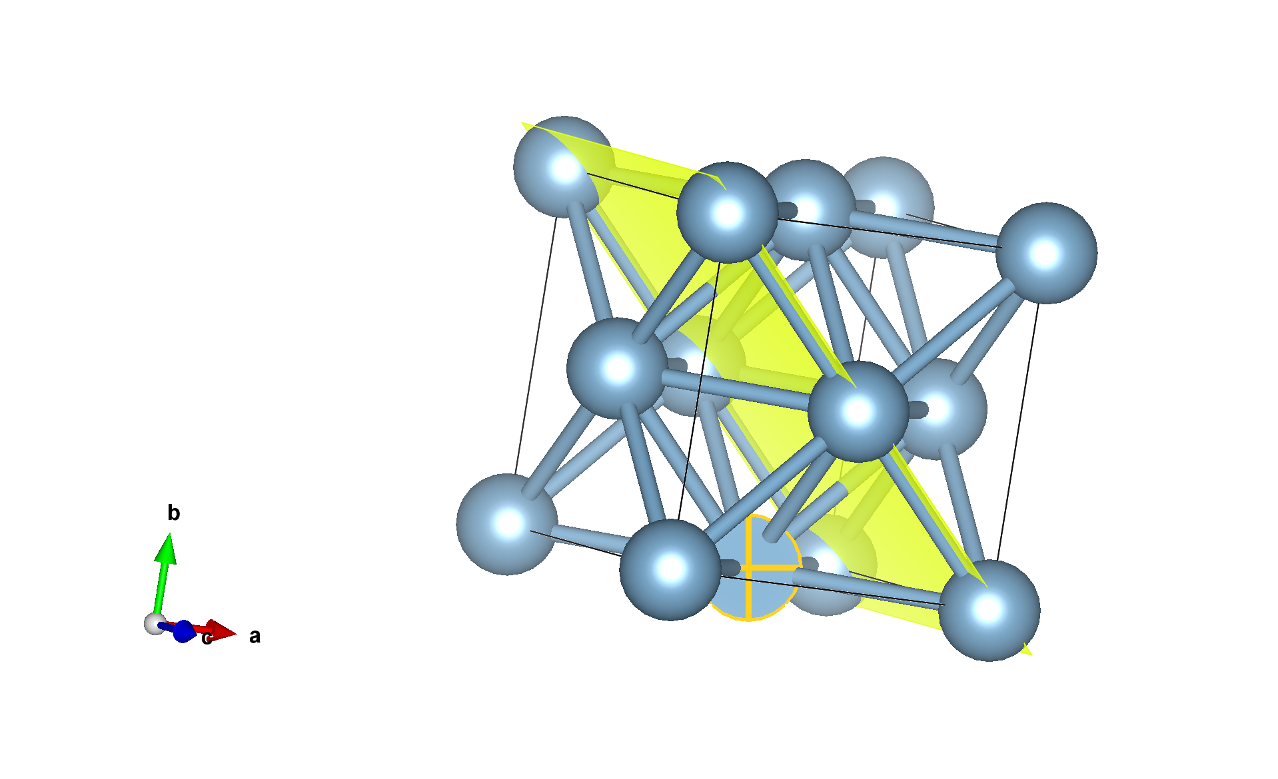

Now, we follow same steps to construct (2 0 0), (1 1 0) and (1 1 1) planes for Al and NaCl.

To construct (2 0 0) plane:

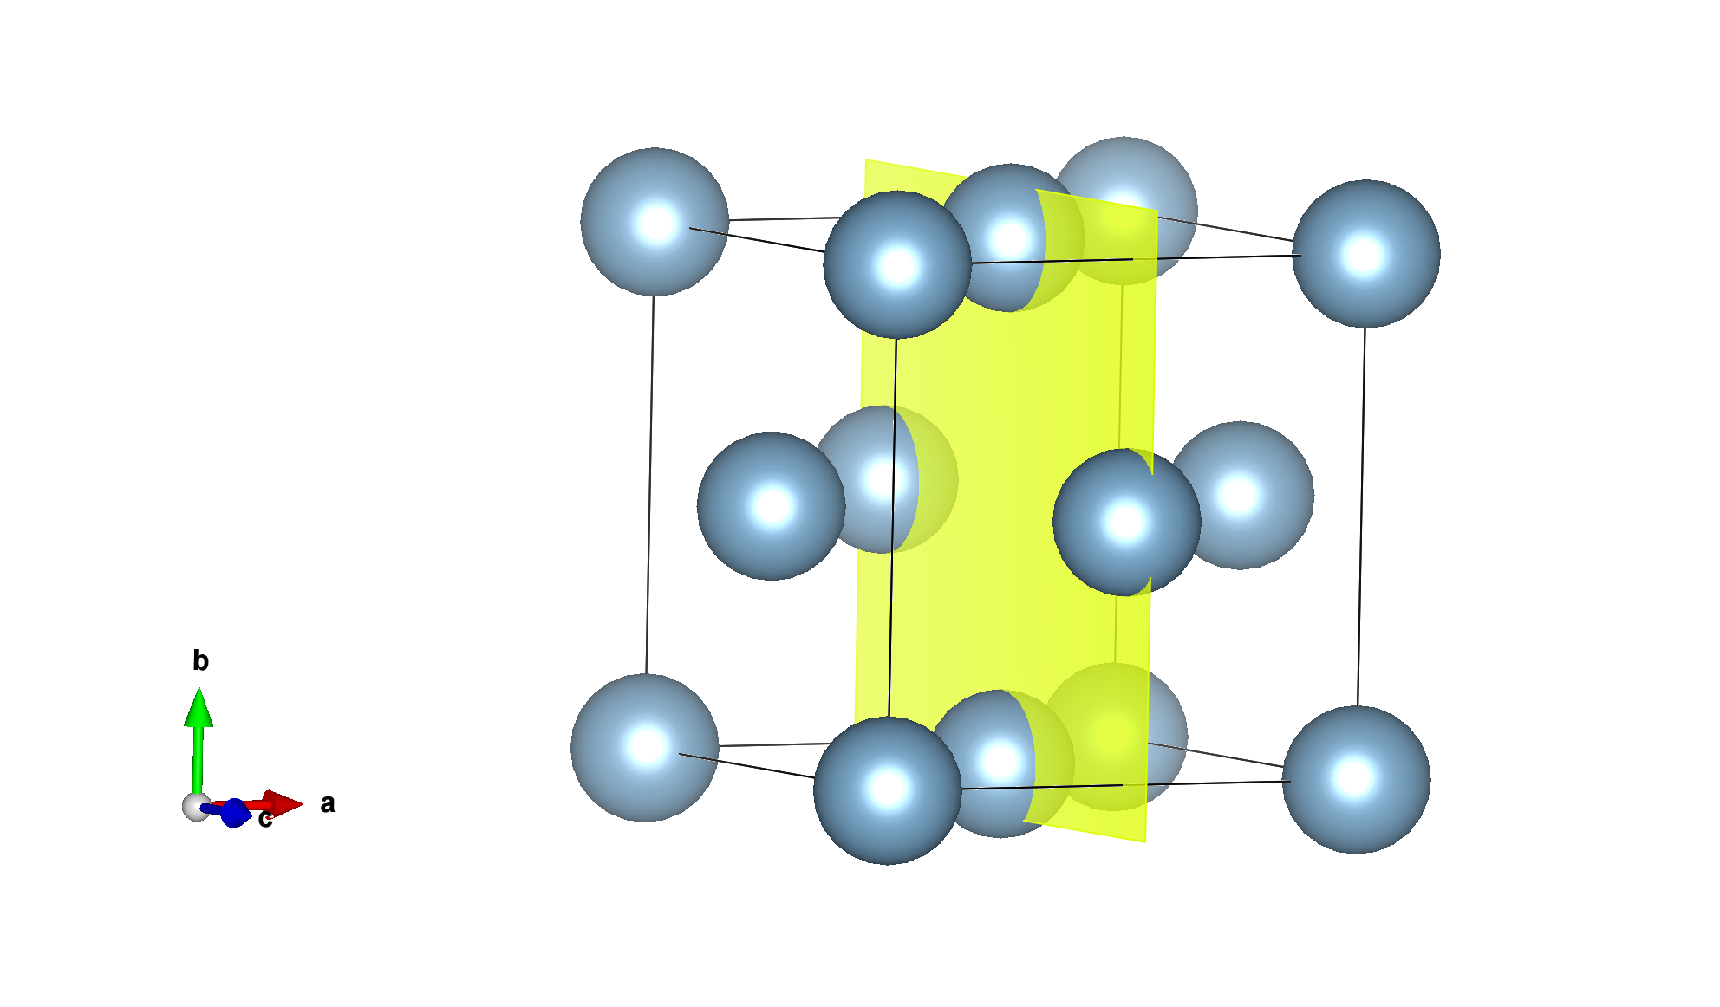

To construct (1 1 1) plane:

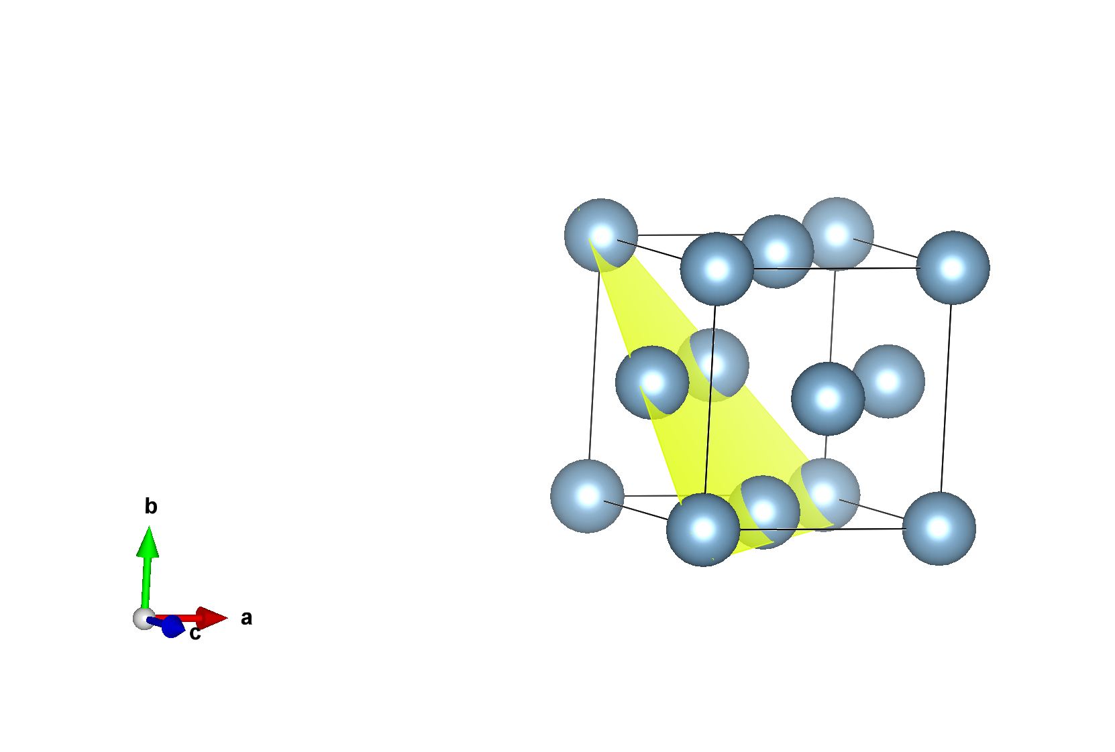

**For NaCl:**

To construct (1 1 0) plane:

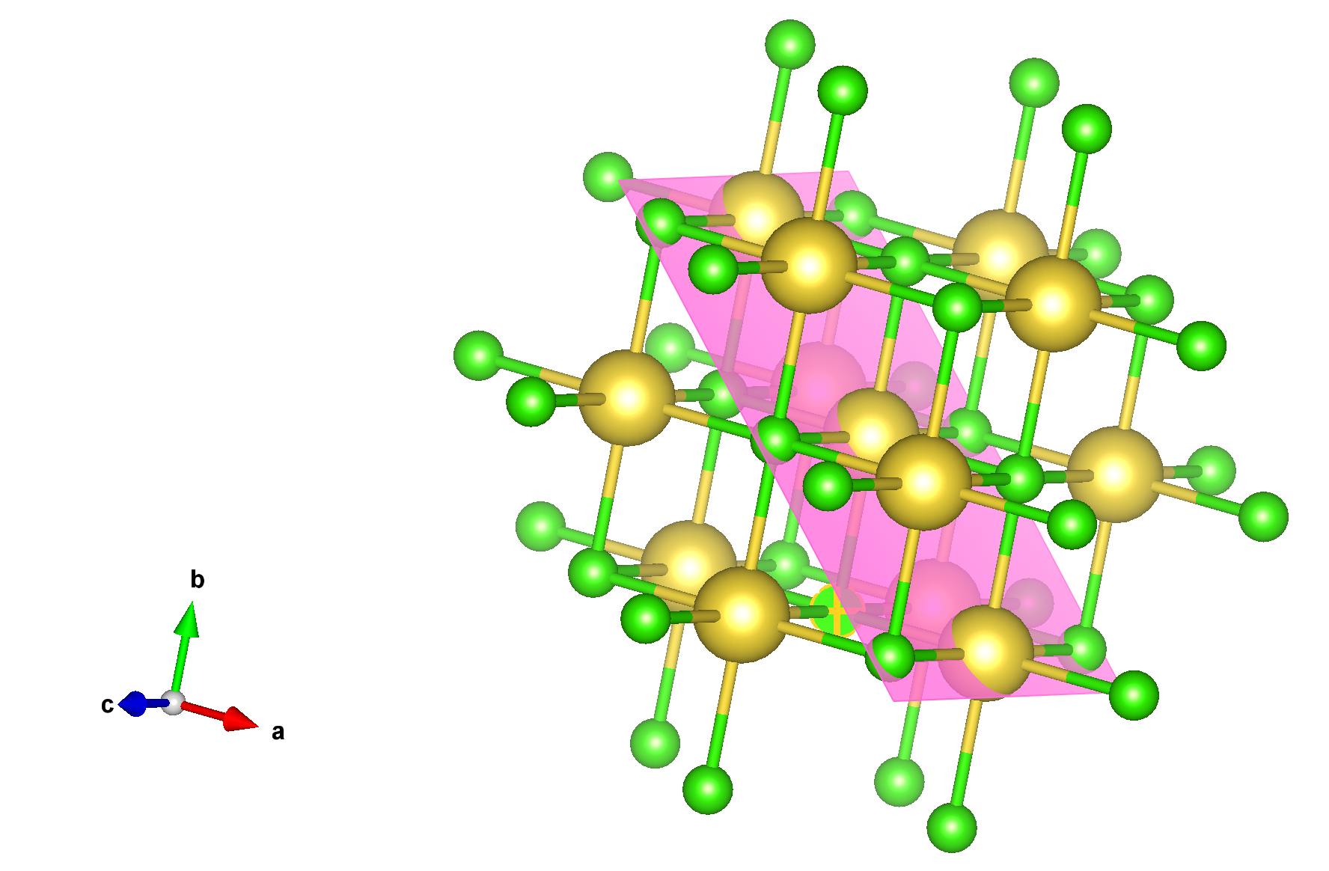

To construct (2 0 0) plane:

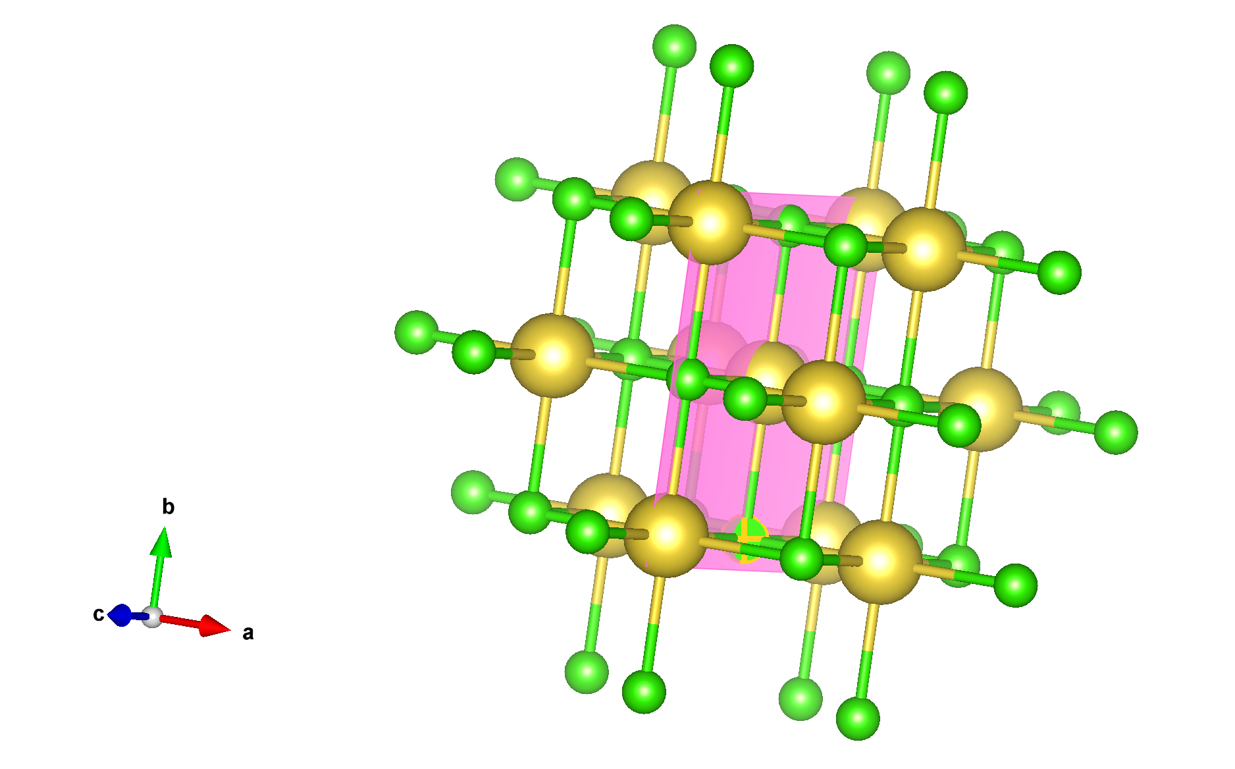

To construct (1 1 1) plane:

